Delivery Manual

Contents -:

- Introduction
- The Role of the Activity Professional
- Leadership Journals
- Mentoring
- Active Supported Delivery - Layout
- Active Supported Delivery – Zone Themes
- Equipment
- Resources
- Wet playtime plans

Introduction

What is the ‘PLAYMaker’ programme?
The PlayMaker Award is a great introduction into leadership giving pupils the knowledge of how to organise small games and activities that can be used during lunch times and break times.

The PlayMaker Award aims to help pupils develop leadership skills such as organisation, communication and teamwork, as well as helping to build confidence and self-esteem as they take on the responsibility of assisting in leading children throughout the school.

How does the ‘PLAYMakers’ programme work?

- Eight children will be selected from years 5 & 6 to be the ‘PlayMakers’ for 6-7 weeks.
- Those eight will take part in a weekly mentoring session with the Premier Sport Activity Professional
- The eight children will also deliver lunchtime activity sessions with the full supervision of the Activity Professional
- Pupils will work towards the PlayMakers completion certificate which takes 6-7 weeks to complete
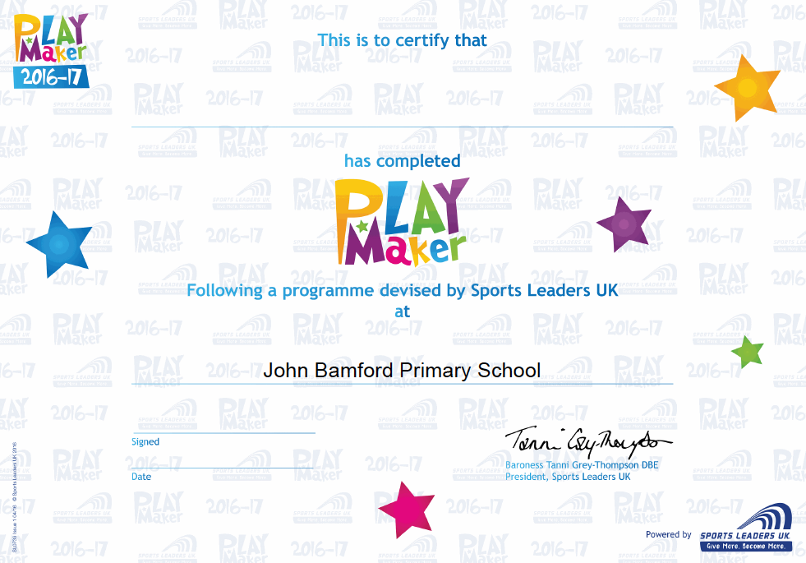

The role of the Activity Professional

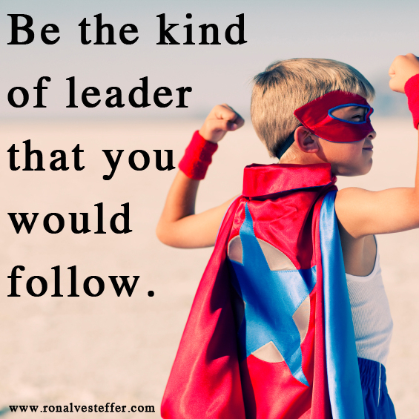
As an Activity Professional, you are potentially the closest a child will come to meeting their sporting heroes. As a mentor you have the opportunity to inspire a child in so many positive ways. This programme offers a unique opportunity to work with small groups of children, to take them under your wing and to produce positive experiences that can lead to great things.

Leadership Journals

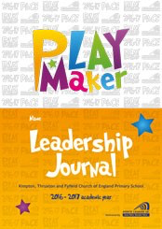
- Each PlayMaker receives their very own Leadership Journal to record their progress throughout the award.

- The leadership journal is kept by the school to evidence impact. PlayMaker’s will use it to note information that will help them become the best leader they can be. They can record what they did as a leader, what experiences they had and how they learnt from them.

Mentoring Sessions

A major selling point to this programme is the mentoring support sessions.

Each session is dedicated to the current PlayMakers for-:

- Meeting and liaising with their Mentor (You)
- Planning and practicing skills, games and sessions
- Completing their Leadership Journals
- Sharing their experiences and ideas

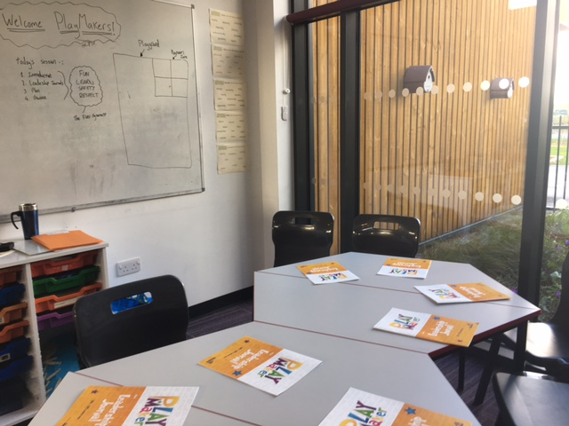

Mentoring sessions should take place in a designated area such as a classroom, library or other suitable breakout area.

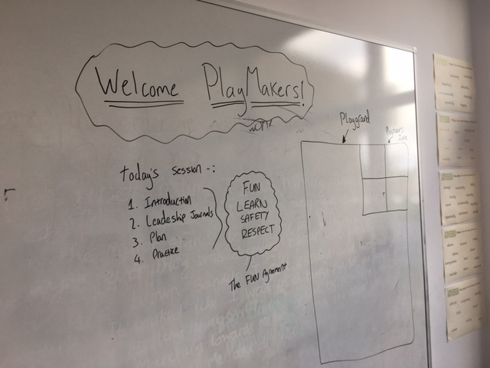
Utilise other resources…..

- White boards (fixed and portable)
- Screens/Projectors
- Official PlayMakers resources (printable)

Tip: Meet the PlayMakers at the lunch table and have a chat with them over lunch.

Active Supported Delivery – Layout

Zone 2
Zone 1

Zone 3
Zone 4

Notes-:

- Use cones to mark out the area on the playground/field

Active Supported Delivery – Zone Themes

Equipment Zones

Bat & Ball Zone
Bean Bag Zone
Hula Hoop Zone

Cone Zone

Other zone ideas-:

Active Supported Delivery – Zone Themes

Sports Zones

Tag Rugby Zone
Dodgeball Zone
Basketball Zone

Handball Zone

Other zone ideas-:
- Football Zone
- Netball Zone

Active Supported Delivery – Zone Themes

Skill Zones

Teamwork Zone
Accuracy Zone
SAQ Zone

Personal Best Zone

Other zone ideas-:

Resources

There is a wealth of resources to support the delivery of the programme which includes -:

- Whole School Awareness Assembly presentation
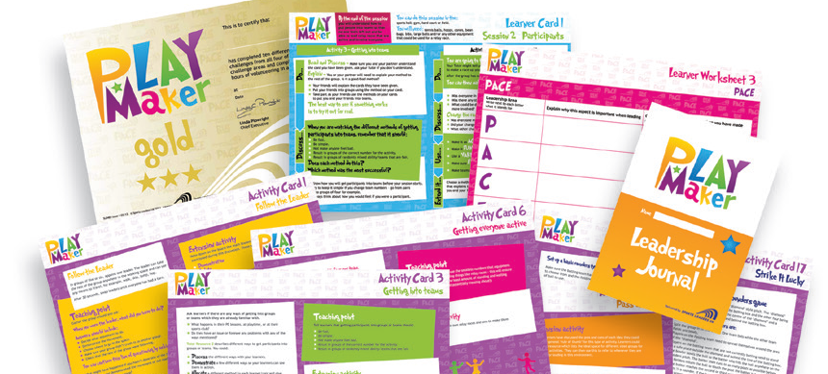
- Tutor Resources
- Leaner Cards
- Learner Worksheets

To access the resources visit the address below…..

https://1drv.ms/b/s!AsJX59Edj5x4gjGqaEsQk0hbKWL2

Wet Weather

During PlayMakers the weather may not always be on our side and as such you are likely to experience wet weather playtimes. During times like these the school children usually spend their playtime in various classrooms.

As PlayMakers we want to ensure that we are making an ‘impact’ whatever the weather.

We have specific games and activities, which require minimal/no equipment, meaning they can take place in classrooms or tight spaces.

Below are a list of some games that can be practiced and delivered by the PlayMakers……

Splat
Have all children stood in a circle next to one another facing inwards, have the teacher stood in the middle being the ‘splatter’. The splatter will individually splat one child at a time, pointing at them shouting the word splat. The child who has been splatted must then duck and stay down, causing the two children either side of them to splat each other. The person who says splat first wins resulting in the loser to sit down.

Heads down thumbs up
Have all children sat on a chair in a classroom with their head on the table and their thumbs pointing in the air ensuring nobody is looking. Choose three children to walk around and pinch a thumb of somebody of their choice. On the teachers demand children can lift their heads and stand up if they had their thumb pinched to stand up.

Elephant ball
Have all children stood in a circle, feet apart so the ball can travel through and feet touching with the person next to them. Children must try and slap/push the ball using one hand through other players legs. Children have two life's, once their life's are up they sit down. The person left standing alone is the winner.

Bounce clap
The teacher has a ball and the pupils must clap every time the teacher bounces the ball. Teacher can use different techniques to try and catch the children out.

The ‘Wobble game

