# Brand New Email Signatures Are Here!

Please update your signatures to the new version (below) - you can do this through outlook by copying and pasting the signature. Here are some simple instructions:

**Your Name Here,**  
Physical Activity & Sport Co-ordinator

**m:**+44 (0)7500 666 666 | **t:**+44(0)1953 499 040 | **e:**youremail@premier-education.com

|  |  |  |  |  |
| --- | --- | --- | --- | --- |
| [Premier Education Group](http://www.premier-education.com/) | [Premier Sport](http://sport.premier-education.com/) | [Premier Performing Arts](http://perform.premier-education.com/) | [Premier Transition](http://premiertransition.co.uk/) | [The Golden Mile](http://www.golden-mile.org/) |

|  |  |  |  |  |  |  |
| --- | --- | --- | --- | --- | --- | --- |
| [Facebook](http://ow.ly/Tudk308WY4K) | [Twitter](http://ow.ly/P4xd308WYan) | [YouTube](http://ow.ly/fzpy308WYg4) | [LinkedIn](http://ow.ly/DLO1308WYmp) | Working in partnership with: | [Premier Foundation](http://www.premierfoundation.org.uk/) | [Donate](http://ow.ly/RzJB308X2wj) |

We are a responsible business – if you need to print this email or any attachments, please reuse and recycle the paper

This email and any attachments to it are confidential and intended solely for the individual or organisation to whom they are addressed. You must not copy or retransmit this e-mail or its attachments in whole or in part to anyone else without our permission. If you are not an intended recipient, please delete the material from any computer that may have it and contact Premier Education Group +44 (0) 1953 499040. Thank you for your co-operation. The views expressed in them are those of the individual author and do not necessarily represent the views of this company. The contents of an attachment to this email may contain software viruses which could damage your computer system. We cannot accept liability for any damage which you sustain as a result of software viruses. You should carry out your own virus checks before opening any attachment.

**Signature Set-Up**

1. Open up a new email in outlook

2. go to "insert" and the "signature" dropdown:

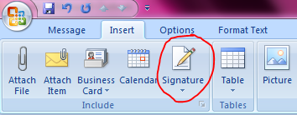

3. Click "signatures":

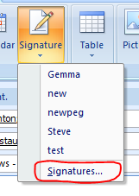

4. Highlight all of your current signature and press backspace to delete it. Paste the new signature in the highlighted box below:

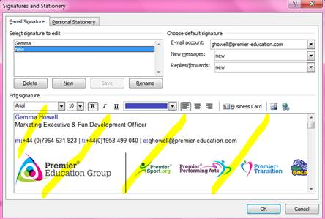

5. Select it as your default signature, then press "ok"

**Customisation:**

Once you have completed the above actions and set up your new signature, you may wish to customise where the social links go to (i.e. your PEG Facebook page). Here is how you can do this...

1. Open up a new email (this should display your new signature at the bottom)

2. Right click on one of the social icons, i.e. Facebook icon:

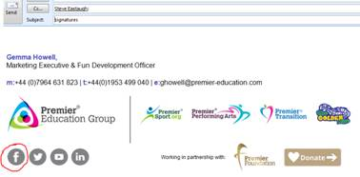

3. Click "edit hyperlink"

4. Replace the URL with the URL to your PEG Facebook page and click "ok"

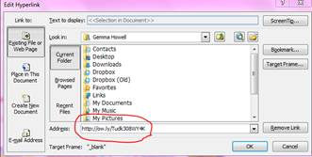

5. Repeat process with any other social link you'd like to replace with your own

6. Copy the whole signature

7. Repeat the "Signature Set-Up" process above but with your newly copied signature

If you have a MAC or any other system other than outlook, you may have some difficulties setting up your new signatures. If this is the case, or you have any other questions relating to the new email signatures, please contact [marketing@premier-education.com](mailto:marketing@premier-education.com) and we will advise.