CQI Email Templates for Schools

CQI Email Template 1

Dear [insert name or sir/madam],
As you know, every year we run a National ‘Continuous Quality Improvement’ survey which we send out to over 2500 schools in England. The results inform the direction, development and priorities for improvement for the coming year, at both national and local level. It influences change and enhances the work we do to ultimately improve the service we deliver to you and your children. As well as our delivery, the survey also asks for feedback to ensure our local leadership and management and customer service we provide you is to the highest standard (and what we need to do to improve if not!).
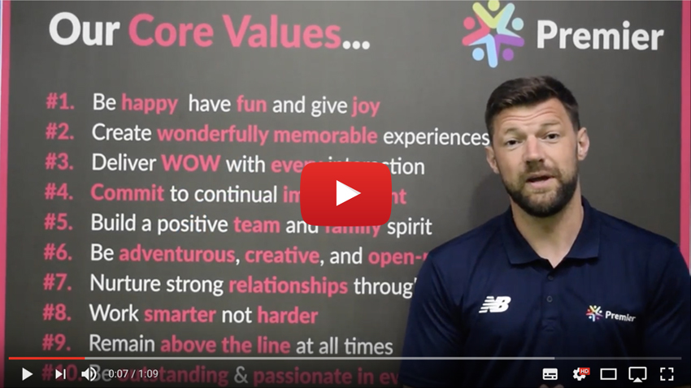
Your honest opinion and feedback is incremental to us achieving one of our core values ‘commit to continual improvement’ – CLICK HERE to fill out our 2018 CQI survey
Thank you!
Every school to submit a survey will be entered into a prize draw to WIN A PREMIER AMBASSADOR VISIT and assembly hosted by your Premier Franchisee to say thank you for your feedback and create a wonderfully memorable experience for your school and children (media team can be provided to capture this moment for your school) -The winner will be announced on Monday 18th June.
The deadline to fill out the survey is Friday 15th of June to Give us time to collate and share the results.

CQI Email Template 2 – Post completion of survey

Dear [insert name or sir/madam],
Many thanks for completing the annual CQI survey in my previous email, we are hugely grateful for your feedback which can reinforce our commitment to continual improvement and look to offer you the best quality of service to you and your school – delivering the WOW with every interaction.
I am delighted to have entered your school into a Prize Draw to win an ambassador visit, the winner will be drawn at random and announced on Monday 18th June – we have our fingers crossed for you.
We will follow up in due course to discuss the results and address any areas for further improvement.

