Let us help you to take Drama to the next level in your school!
In a nutshell...
Here at Premier Performing Arts (PPA) we are passionate about providing children & young people white drama classes that are not only fun and exciting but also which develop key social skills such as confidence, concentration, co-operation and creative problem solving. Through our unique programme which combines the disciplines of drama, movement, music and play, we help children and young people explore and make sense of, the work in which they live.
The entire Premier Performing Arts programme has been written and developed by an experienced drama teacher and supports the current requirements of the National Curriculum, ensuring that young children develop the skills and understanding to progress happily and successful through their preschool years right through to secondary school.
So what does this mean to your pupils?
Drama, pretending and role-play are some of the most instinctive things that children do. They laugh, they play, they learn. At this young age, drama is how children make sense of the world around them; they recreate events that happen to them, use their imaginations to explore different worlds and role-play characters to see how they fit into it all. PPA allows children to lead the way in drama by cleverly mixing improvisation with structured classes.
10 benefits of Drama in your school…
- Drama builds confidence
- Drama helps concentration
- Drama helps develop language & communication skills
- Drama encourages children to co-operate
- Drama supports numeracy skills
- Drama helps children to understand the world around them
- Drama develops emotional intelligence
- Drama assists physical development
- Drama develops creativity
- Drama nurtures friendships
So how can you get involved?
Overleaf is a voucher for you to activate your FREE Drama workshop. All you have to is call us on (telephone number here) and quote DRAMA WORKSHOP to book it in.

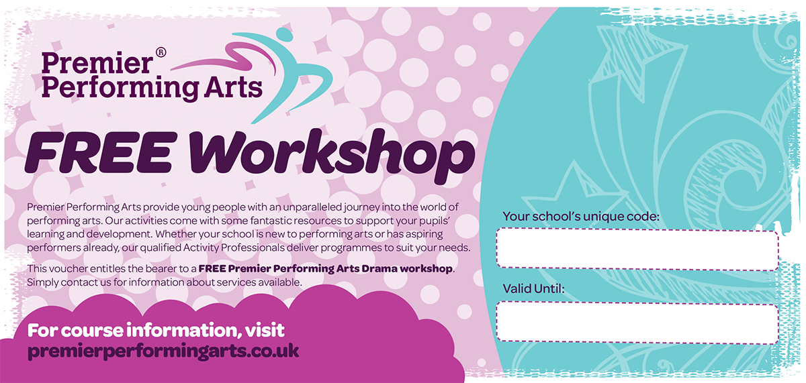

To redeem this voucher, contact (Insert Tel No here)

UNIQUE-SCH-CODE

26th June 2016

We can’t wait to hear from you!

Kind regards,
Frankie Worthington
National Director
Premier Education Group

