Golden Mile PR Plan

Objective;
To increase the number of schools registered with The Golden Mile from 1,254 to 1,600 and increase brand awareness.

Positioning and background
- Over three quarters of parents admit they are concerned that their child is less physically active than they were at same age
- Almost 40% of parents admit their child is less active than them at the same age
- Over half of parents say that they notice a difference in their child’s behaviour after physical activity, with over half agreeing they are happier. A quarter say they are better at listening and 30% said they have improved concentration.
- Children are spending almost double the amount of time a week on a tablet or watching TV, than doing any type of physical activity.
- Three quarters of parents admit they do not know how long their child should be active for each day
- Almost 2 in 5 parents would not know how to decide if their child had been physically active for
- Just under 1 in 5 parents assume that their child is kept physically active during school
- Almost a third of parents admit they let their child decide if they have been physically active enough
- Over 2 in 5 children currently get their 60 minutes of recommended daily exercise by walking to and from school
- 40% say their child is most likely to get their 60 minutes of recommended daily exercise whilst on holiday
- Over 40% of parents say that they would like their child's school to accurately measure how much physical activity their child receives. 2 in 5 say they would like their child’s school to incorporate an active mile scheme

Overview of The Golden Mile
- The Golden Mile is a safe, simple and measurable health & safety initiative accessible to all age groups regardless of ability.

- The Golden Mile has been operating in schools for over 10 years.

- The Golden Mile has resulted in 1 million miles of activity recorded between January 2016 and 2017.

- The Golden Mile is aimed at schools across the UK and beyond, with the intention of getting kids more active, through running, jogging and walking recordable miles around a preset track in the comfort of their own school.

- Participants use the downloadable resources to upload the number of laps pupils achieve easily. Interactive school and class pages convert laps into miles and display the pupil’s progress via graphs and league tables.

- The Golden Mile encourages teachers to champion and take ownership of their class progress along with the pupils. As soon as they register the class competitions can begin.

- The Golden Mile aims to inspire and encourage participants with a focus on fun, rewarding personal achievement, raising money and healthy competition.

- The Golden Mile encourages pupil leadership skills, they are encouraged to get involved with recording laps, uploading class data to the system and printing data graphs and certificates.

- The Golden Mile can be delivered all year round and encourages healthy habits to be formed.

- The Golden Mile was featured on ITV’s Tonight Show ‘The Truth About Exercise’ showing the healthy changes The Golden Mile has made with a partner school in the North West of the UK.

- The Golden Mile is endorsed by Premier Sport; the UK’s largest sport and physical activity company of its kind.

- The Golden Mile is partnered with Change 4 Life.

- The Golden Mile has resulted in enough miles being completed to travel around the world 253 times!

- In the last year 85,000 children have registered for The Golden Mile.

- The Golden Mile gets 40,000 children active per month.

- The Golden Mile has received recognition from Ofsted, for its support of children’s physical activity and wellbeing.

- The Golden Mile is part of the Premier Education Group which includes Premier Sport, Premier Performing Arts and Premier Transition. The group works in over 3,000 primary schools and community settings throughout the UK.

- Obesity and inactivity in young people is one of the biggest challenges facing children of the UK and the world, and is something Premier is fully committed to addressing.

Dame Kelly Holmes DBE

- Dame Kelly Homes was born 19th April 1970 and is a retired British middle distance athlete.

- She specialised in the 800m and 1500m events and won the gold medal for both distances at the 2004 summer Olympics in Athens.

- Kelly has set British records in numerous events and still holds the records across the 600m, 800m and 1,000m distances.

- She is founder and president of The Dame Kelly Holmes Legacy Trust, following her successful athletics career she wanted to create a legacy that would benefit young people. Believing that every child needs a hero, someone to look up to and be inspired by.

- In 2013 Kelly became the face of MoneyForce – a programme run by the British Royal Legion to deliver money advice to the UK Armed Forces having joined the British Army during her youth.

Regional Research Breakdown

East Anglia
- 88% of parents in East Anglia admit they are concerned that their child is less physically active than they were at same age
- 3 in 5 parents in East Anglia say that they notice a difference in their child’s behaviour after physical activity, with over half agreeing they are happier. 30% say they are better at listening and over a third said they have improved concentration.
- Children are spending almost double the amount of time a week on a tablet or watching TV, than doing any type of physical activity.
- Nearly three quarters of parents admit they do not know how long their child should be active for each day
- 2 in 5 parents in East Anglia would not know how to decide if their child had been physically active for
- 41% of parents admit they let their child decide if they have been physically active enough
East Midlands
- 9 in 10 parents in the East Midlands admit they are concerned that their child is less physically active than they were at same age
- Nearly 60% of parents in the East Midlands say that they notice a difference in their child’s behaviour after physical activity, with almost two thirds agreeing they are happier. A quarter say they are better at listening and more than a third said they have improved concentration.
- Children are spending almost double the amount of time a week on a tablet or watching TV, than doing any type of physical activity.
- Three quarters of parents in the East Midlands admit they do not know how long their child should be active for each day
- 44% of parents would not know how to decide if their child had been physically active for
- Over 38% of parents in the East Midlands admit they let their child decide if they have been physically active enough
London
- 88% of parents in London admit they are concerned that their child is less physically active than they were at same age
- Almost 60% of parents say that they notice a difference in their child’s behaviour after physical activity, with more than half agreeing they are happier. More than a quarter say they are better at listening and 30% said they have improved concentration.
- Children are spending almost double the amount of time a week on a tablet or watching TV, than doing any type of physical activity.
- 84% of parents admit they do not know how long their child should be active for each day
- Almost half of parents in London would not know how to decide if their child had been physically active for
- 30% of parents admit they let their child decide if they have been physically active enough
North East
- 8 in 10 parents in the North East admit they are concerned that their child is less physically active than they were at same age
- Almost half of parents say that they notice a difference in their child’s behaviour after physical activity, with almost two thirds saying they feel happier. More than a quarter say they are better at listening and a third said they have improved concentration.
- Children are spending almost double the amount of time a week on a tablet or watching TV, than doing any type of physical activity.
- More than three quarters of parents in the North East admit they do not know how long their child should be active for each day
- 38% of parents in the North East would not know how to decide if their child had been physically active for
- Over a quarter of parents admit they let their child decide if they have been physically active enough
North West
- Two thirds of parents in the North West admit they are concerned that their child is less physically active than they were at same age
- 3 in 5 parents say that they notice a difference in their child’s behaviour after physical activity, with 62% agreeing they are happier. 30% said they are better at listening and more than a quarter said they have improved concentration.
- Children are spending almost double the amount of time a week on a tablet or watching TV, than doing any type of physical activity.
- More than 80% of parents admit they do not know how long their child should be active for each day
- Over a third of parents in the North West would not know how to decide if their child had been physically active for
- More than a third of parents admit they let their child decide if they have been physically active enough
Northern Ireland
- 70% of parents in Northern Ireland admit they are concerned that their child is less physically active than they were at same age
- Almost two thirds of parents say that they notice a difference in their child’s behaviour after physical activity, with 83% agreeing they are happier. A third said they are better at listening and 44% said they have improved concentration.
- Children are spending almost double the amount of time a week on a tablet or watching TV, than doing any type of physical activity.
- 80% of parents in Northern Ireland admit they do not know how long their child should be active for each day
- A third of parents would not know how to decide if their child had been physically active for
- 1 in 5 parents admit they let their child decide if they have been physically active enough
Scotland
- More than three quarters of parents in Scotland admit they are concerned that their child is less physically active than they were at same age
- Over 57% of parents in Scotland say that they notice a difference in their child’s behaviour after physical activity, with 60% agreeing they are happier. 1 in 5 said they are better at listening and almost 30% said they have improved concentration.
- Children are spending almost double the amount of time a week on a tablet or watching TV, than doing any type of physical activity.
- Three quarters of parents admit they do not know how long their child should be active for each day
- More than a third of parents would not know how to decide if their child had been physically active for
- Over a third of parents in Scotland admit they let their child decide if they have been physically active enough
South East
- 80% of parents in the South East admit they are concerned that their child is less physically active than they were at same age
- 54% of parents say that they notice a difference in their child’s behaviour after physical activity, with more than half agreeing they are happier. 30% said they are better at listening and more than a quarter said they have improved concentration.
- Children are spending almost double the amount of time a week on a tablet or watching TV, than doing any type of physical activity.
- Three quarters of parents admit they do not know how long their child should be active for each day
- 42% of parents in the South East would not know how to decide if their child had been physically active for
- 30% of parents in the South East admit they let their child decide if they have been physically active enough
South West
- 3 in 5 parents in the South West admit they are concerned that their child is less physically active than they were at same age
- Two thirds of parents say that they notice a difference in their child’s behaviour after physical activity, with more than half agreeing they are happier. 15% said they are better at listening and nearly 30% said they have improved concentration.
- Children are spending almost double the amount of time a week on a tablet or watching TV, than doing any type of physical activity.
- More than 70% of parents admit they do not know how long their child should be active for each day
- Over 37% of parents would not know how to decide if their child had been physically active for
- 30% of parents in the South West admit they let their child decide if they have been physically active enough
Wales
- Over 71% of parents in Wales admit they are concerned that their child is less physically active than they were at same age
- 55% of parents say that they notice a difference in their child’s behaviour after physical activity, with more than half agreeing they are happier. A quarter said they have improved concentration.
- Children are spending almost double the amount of time a week on a tablet or watching TV, than doing any type of physical activity.
- Two thirds of parents in Wales admit they do not know how long their child should be active for each day
- 2 in 5 parents in Wales would not know how to decide if their child had been physically active for
- Over a quarter of parents in Wales admit they let their child decide if they have been physically active enough
West Midlands
- 9 in 10 parents in the West Midlands admit they are concerned that their child is less physically active than they were at same age
- More than 57% of parents say that they notice a difference in their child’s behaviour after physical activity, with half agreeing they are happier. 22% said they are better at listening and almost 30% said they have improved concentration.
- Children are spending almost double the amount of time a week on a tablet or watching TV, than doing any type of physical activity.
- 85% of parents admit they do not know how long their child should be active for each day
- More than 37% of parents would not know how to decide if their child had been physically active for
- Almost 70% of parents in the West Midlands admit they let their child decide if they have been physically active enough
Yorkshire and Humber
- Three quarters of Yorkshire and Humber admit they are concerned that their child is less physically active than they were at same age
- Almost half of parents say that they notice a difference in their child’s behaviour after physical activity, with more than half agreeing they are happier. 2 in 5 said they are better at listening and over a quarter said they have improved concentration.
- Children are spending almost double the amount of time a week on a tablet or watching TV, than doing any type of physical activity.
- Nearly three quarters of parents in Yorkshire and Humber admit they do not know how long their child should be active for each day
- 70% of parents would not know how to decide if their child had been physically active for
- 1 in 5 parents in Yorkshire and Humber admit they let their child decide if they have been physically active enough

Facebook
@premiertransition @premiersport @premierperformingarts @PremierEducationGroup

Friday 12th May 2017 AM
The Golden Mile is a safe, simple and measurable health and safety initiative accessible to all age groups regardless of ability. It aims to inspire and encourage participants with a focus on fun, rewarding personal achievement, raising money and healthy competition. Keep your eyes peeled for our Go For Gold Challenge – nominate your child’s school here - http://sport.premier-education.com/children-families/gfg-nominate #GoForGoldChallenge

Friday 12th May 2017 PM
Did you know next week is National Walk to School Week, get involved with The Golden Mile and Dame Kelly Holmes...
The Golden Mile is a safe, simple and measurable health and safety initiative accessible to all age groups regardless of ability. It aims to inspire and encourage participants with a focus on fun, rewarding personal achievement, raising money and healthy competition.
#comingsoon #keepaneyeout #GoForGoldChallenge

Saturday 13th May 2017
COMPETITION: #NationalWalkingCompetition! Nominate your child’s school to start The Golden Mile for your chance to win a Dame Kelly Homes Legacy Trust Athlete visit to your child’s school! http://sport.premier-education.com/children-families/gfg-nominate #GoForGoldChallenge
#WalkToSchool #NationalWalkingMonth @livingstreetsuk

Sunday 14th May 2017
This week we will be raving all about The Golden Mile and the benefits it has on children’s health and wellbeing! We will also be letting you know about our #NationalWalkingCompetition! Listen out for Dame Kelly Holmes across Radio and keep your eyes peeled on TV this Wednesday to hear more about this great initiative. Schools – find out more here and sign up for FREE http://sport.premier-education.com/schoolservices/goforgold #WalkToSchool #NationalWalkingMonth #GoForGoldChallenge @damekellyholmestrust

Monday 15th May 2017
Today marks the start of National Walk to School Week! Keep your eyes peeled this Wednesday for Dame Kelly Holmes talking about The Golden Mile on TV and Radio... #GoForGoldChallenge

Tuesday 16th May 2017
National Walking Month is here! Who's clocking up the miles? #Try20

Wednesday 17th May 2017
Look how many miles children clocked up through The Golden Mile in the last year!... #NationalWalkingMonth
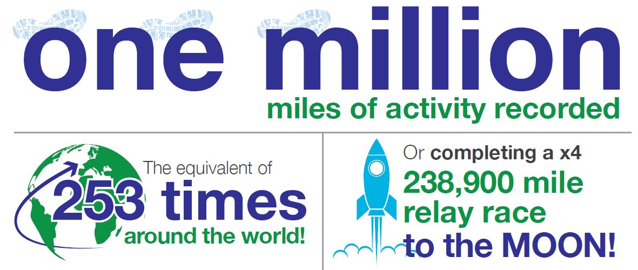

Wednesday 17th May 2017
Did you see Dame Kelly Holmes this morning on Sky Sunrise, or did you hear us on BBC R2? Talking all about The Golden Mile and the #GoForGoldChallenge! Schools, sign up now for free - http://sport.premier-education.com/schoolservices/goforgold #National WalkingMonth #TheGoldenMile

Thursday 18th May 2017
We've had 85,000 new children registered to The Golden Mile in the last year... #NationalWalkingMonth
Friday 19th May 2017
The Golden Mile gets on average 40,000 children active per month! #NationalWalkingMonth
There is still time to nominate your school and win a Dame Kelly Homes Legacy Trust Athlete visit to your child’s school! http://sport.premier-education.com/children-families/gfg-nominate #GoForGoldChallenge!
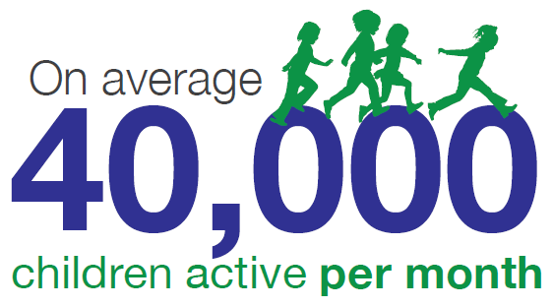
Friday 19th May 2017
We employ over 1,000 Activity Professionals to support your children to get physically active in the UK... #NationalWalkingMonth
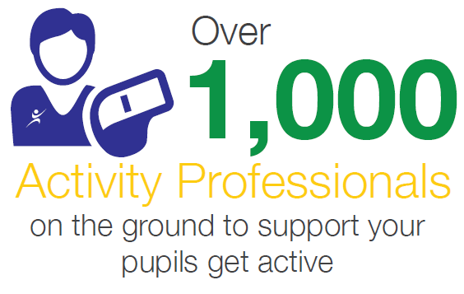
Twitter

@The_Golden_Mile @PremTransition @premsport @PremEducation @PPerformingArts
Thursday 08th May 2017 AM
Keep your eyes peeled, The Golden Mile will be endorsed by an Olympic Athlete and a FREE competition launched next week! #GoForGoldChallenge #TheGoldenMile #Healthyfutures http://sport.premier-education.com/schoolservices/goforgold

Tuesday 09th May 2017 PM
May is National Walking Month, is your school keeping active? Try the Golden Mile for FREE with the #GoForGoldChallenge and win prizes! http://sport.premier-education.com/schoolservices/goforgold

Friday 12th May 2017 AM
Incredibly proud to have @damekellyholmes support The Golden Mile and launch our #GoForGoldChallenge #Healthyfutures http://sport.premier-education.com/schoolservices/goforgold

Friday 12th May 2017 PM
The Golden Mile is a safe, simple and measurable health and physical activity iniative! Join for FREE with the #GoForGoldChallenge and start collecting! http://sport.premier-education.com/schoolservices/goforgold

Monday 15th May 2017
Listen to us on BBC R2 at 8:45 this Wednesday 17th. We will tell you all about the #GoForGoldChallenge with @damekellyholmes and what you can win!

Tuesday 16th May 2017
You early birds, check us out on Sky Sunrise tomorrow at 7:15am! Chatting all things Golden Mile @damekellyholmes #GoForGoldChallenge

Wednesday 17th May at 7:15am
@DameKellyHolmes is now live with Sky Sunrise to launch the #GoForGoldChallenge with The Golden Mile! #HealthyFutures

Wednesday 17th May at 8:45am
@DameKellyHolmes is now live with BBC RADIO 2 to launch the #GoForGoldChallenge with The Golden Mile! #HealthyFutures

Wednesday 17th May 2017 AM
Did you see us @damekellyholmes on TV this morning talking about the Golden Mile? If you missed it, find out more here #GoForGoldChallenge http://sport.premier-education.com/schoolservices/goforgold

Wednesday 17th May 2017 PM
Did you hear us on BBC R2 this morning? If you missed us, find out more about the #GoForGoldChallenge here http://sport.premier-education.com/schoolservices/goforgold

Thursday 18th May 2017
The Golden Mile is a safe, simple and measurable health and physical activity iniative! Join for FREE #GoForGoldChallenge! http://sport.premier-education.com/schoolservices/goforgold

Friday 19th May 2017
Sign your school up to The Golden Mile for FREE with the #GoForGoldChallenge for you chance to win prizes! http://sport.premier-education.com/schoolservices/goforgold

Monday 22nd May 2017
Want to win some great prizes? Today marks the start of the #GoForGoldChallenge, you can still sign up and win great prizes! http://sport.premier-education.com/schoolservices/goforgold

Tuesday 23rd May 2017
Have you started collecting your golden miles? Join for FREE with the #GoForGoldChallenge, who will win? http://sport.premier-education.com/schoolservices/goforgold

Wednesday 24th May 2017
We can see those miles racking up! How many has your school run? #GoForGoldChallenge http://sport.premier-education.com/schoolservices/goforgold

Thursday 25th May 2017
There is still time to sign up FREE for the #GoForGoldChallenge, collect your miles and you could win some fantastic prizes! http://sport.premier-education.com/schoolservices/goforgold

Friday 26th May 2017
Why not sign up your school for the #GoForGoldChallenge, there is still plenty of time after half term to collect your miles and win great prizes! http://sport.premier-education.com/schoolservices/goforgold

Half Term

Monday 5th June 2017
Let us know how many miles you have done so far on the #GoForGoldChallenge. Keep active healthy! #TheGoldenMile

Monday 12th June 2017
How many miles you have done for #GoForGoldChallenge? Which school is going to get gold? #TheGoldenMile #Healthyfutures

Wednesday 14th June 2017
We know who is winning so far in the #GoForGoldChallenge, is it you? There is still time to collect those miles for your chance to win an Olympic Athlete Ambassador Visit!

Monday 19th June 2017
Today marks the last week of the #GoForGoldChallenge – final push towards winning those great prizes! #healthyfutures

Monday 26th June 2017
Today marks the finish of the #GoForGoldChallenge, stay tuned for details of the Gold, Silver and Bronze medal winners!! #TheGoldenMile #Healthyfutures

We will tweet to say ‘Check your inboxes today, did you get a medal in the #GoForGoldChallenge? You could be about to find out what prize you won! #healthyfutures

 | Live Stations
Radio Station | Location | Presenter | Date
Sky News Sunrise (arrive 0650 for hair & make up for 0715 interview) | National | Sarah-Jane Mee & Jonathan Samuels | 17.05.2017
BBC Radio 2 (arrive 0830 for 0845 interview) | National | Vassos Alexander & Chris Evans | 17.05.2017
BBC Wiltshire | Wiltshire | Ali Vowls | 17.05.2017
BBC Oxford | Oxfordshire | Kat Orman | 17.05.2017
BFBS | National | Hal Stewart | 17.05.2017
Heart Kent | Kent | Lucy Wilson | 17.05.2017
KMFM | Kent | Joanna Earle | 17.05.2017
Radio Yorkshire | Yorkshire | Danny Parkinson | 17.05.2017
Dee 106.3 | Chester | Phil Munns | 17.05.2017
Siren FM | High Wycombe & surrounding area | Chris Clarkson | 17.05.2017
SFM | Sittingbourne | TBC | 17.05.2017
Meridian FM | East Grinstead | Samantha Day | 17.05.2017
Broadcast List as of 12.05.17

#GoForGoldChallenge
Landing Page - http://sport.premier-education.com/schoolservices/goforgold

As part of the Golden Mile PR Plan, we have created a competition where schools to compete against one another to win some great prizes!

Schools can sign up for FREE for 12 months using the promo code ‘GOFORGOLD’. We are encouraging schools to register before 9am on Monday 22nd May as this is the day the data collection will start. However, schools can register after this date; they will just have less time to collect their miles.

Schools should record the miles they collect between 9am on Monday 22nd May and 9am on Monday 26th June – we will then work out the average miles per pupil collected during this period, and the top schools win their prizes!

The prizes are as follows:
Gold Medal:
5 x Exclusive Olympic Athlete Visits
Silver Medal:
20 x Free sports days this summer in a number of different sports, provided by Premier Sport
Bronze Medal:
50 x Health and wellbeing taster sessions, one for their pupils and one for their teachers and parents to enjoy, provided by Premier Transition

Email Campaign 1 - Distributed on 10.05.17

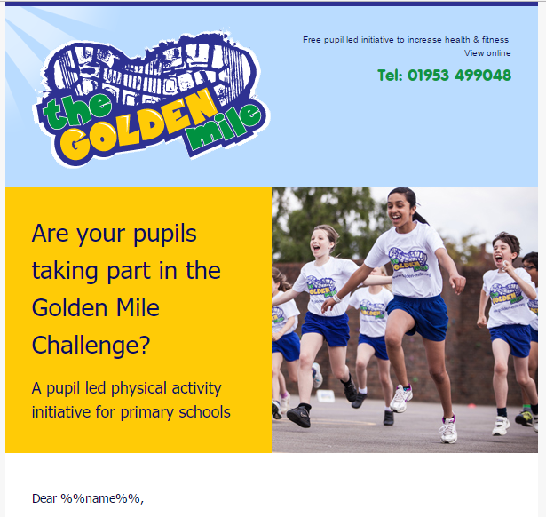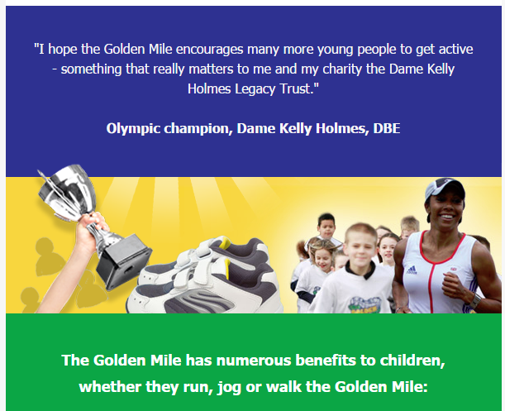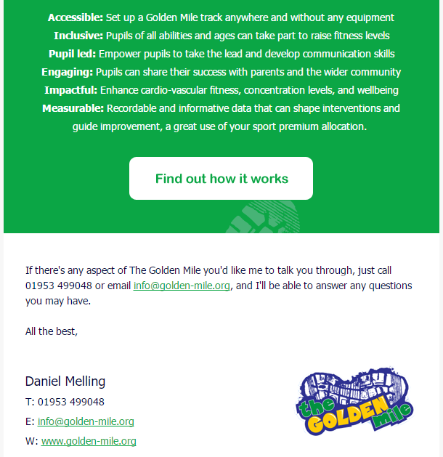

Email Campaign 2 – To be distributed on 17.05.17
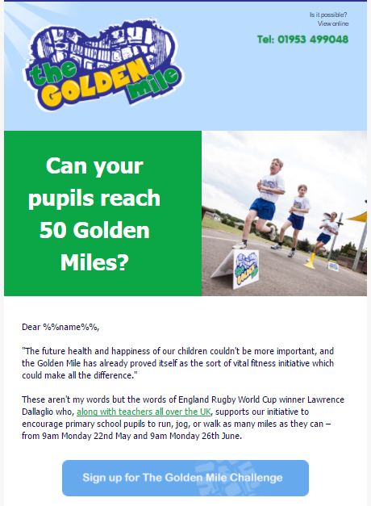
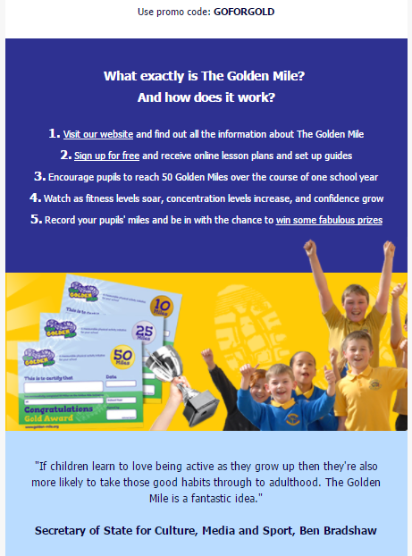
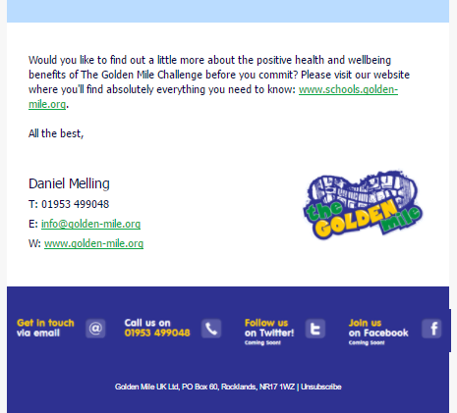

Email Campaign 3 – To be distributed on 25.05.17

