About Premier

Premier is the UK's largest children's coaching company of its kind, successfully delivering more than 25,000 sport and physical activity sessions every month. Premier Sport supports teachers in their curriculum delivery and provides parents with an invaluable service before, during, afterschool and during holiday periods.

Since its inception in 1999 Premier Sport has strived to push the boundaries of what excellent sport and physical education looks like. As a founding member of UK Active Kids and the first organisation of its kind to be awarded the highly prestigious Quality in Study Support (QiSS) kite mark, Premier Sport works closely with schools across the country to inspire children to live a healthy, fit and fun life.

Premier at Meopham Community Academy (MCA)

We have been supporting the physical education and extra-curricular provision at Meopham Community Academy since 2012. Our Ofsted registered Wrap Around Care facility is used by approximately 20% of families and especially those with working parents as it provides a safe, secure and fun environment for children and extra time at either end of the school day for busy parents.
Our Staff
All staff are DBS checked, safeguarding and first aid trained. They are qualified and experienced at working with children in primary school settings. We call them Activity Professionals because we believe that this truly reflects the nature of their role and the dedicated approach they have, to ensuring that your child learns, has fun, is safe and well looked after.
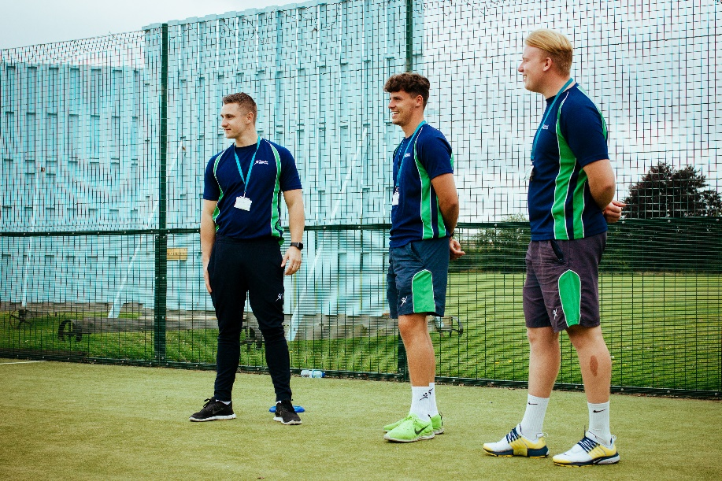

Club Information
Start active club
Time - 07.30-08.35 Ages 4-11 years old Price - £6.00
Give your child a great start to the day! Evidence shows that introducing elements of physical activity to children before school starts can engage their minds and prepare them for the day ahead.
Our Start Active session run for 60 minutes and stimulate the learning experiences of your child.
Children enter the school day alert and ready for the day, having engaged their minds and body whilst learning a host of valuable skills including:
- The importance of being punctual and well prepared for the day
- Be more alert for a day of learning within the school
- Understand the importance of healthy lifestyle
- Improve coordination, balance, agility and flexibility
- Communication appropriately and effectively with others
- Engage and interact appropriately with other children
- Be given realistic challengers to achieve
- Use tactics and strategies to increase chances of success

Food
Working in conjunction with the schools catering provider TCS Independent Ltd we offer a nutritious and varied breakfast menu at the Start Active session.
The menu is shown below:
Monday | Tuesday | Wednesday | Thursday | Friday
Cereal  Toast (with or without Jam)  Yoghurt  Fresh Fruit  Or  Hot Dish of the day:  Baked beans on toast  Drinks:  Milk  Fruit Juice  water | Cereal  Toast (with or without Jam)  Yoghurt  Fresh Fruit  Or  Hot Dish of the day:  Scrambled egg on toast  Drinks:  Milk  Fruit Juice  water | Cereal  Toast (with or without Jam)  Yoghurt  Fresh Fruit  Or  Hot Dish of the day:  Sausage in a roll  Drinks:  Milk  Fruit Juice  water | Cereal  Toast (with or without Jam)  Yoghurt  Fresh Fruit  Or  Hot Dish of the day:  Cheese omelette  Drinks:  Milk  Fruit Juice  water | Cereal  Toast (with or without Jam)  Yoghurt  Fresh Fruit  Or  Hot Dish of the day:  Bacon sandwich  Drinks:  Milk  Fruit Juice  water

Timings

Registration opens at 7.30am and food is served at 8.00am. After the children have eaten and taken part in some fun and games they will be de-registered to their classes when the school bell goes at 8.35am.

Signing in & out

In the morning, you must accompany your child to the door of the hall where a member of staff will greet you and ask you to sign the register indicating that you have handed your child into our care.

Play Active Club

Time – 1st session 15.15-17.00 Price - 1st session £6.00
2nd session 17.00-18.00 2nd session £5.00
Siblings receive 15% discount!

Fun physical activities for everyone, Play Active sessions encourage fun-based physical activities rather than traditional sports. As an extra-curricular programme, it runs directly at the end of the school day. The aim of Play Active is to encourage children to get physically active through structured activities. By placing emphasis on inclusion rather than specific sports skills and techniques, children are encouraged to have fun. This in turn improves social skills, self-esteem, balance, coordination and physical wellbeing.

In addition, children will learn a wide variety of skills that they can use beyond the sports field, including
- Celebrate perseverance and acknowledge achievement
- Engage and interact appropriately with other children
- Set achievable personal goals to reach
- Improve confidence and self-esteem to try something new
- Ability to follow rules and respect themselves and other
- Understand the importance of a healthy lifestyle
- Improve control, coordination, balance, agility and flexibility
- Communicate appropriately and effectively with others

Food & Drink

We recommend that children that attend after school bring a snack and drink with them. The activities are structured to allows snack time from 3.15pm and one at 4.45pm.
In keeping with the school’s policies, we request that children do not bring any fizzy drinks or Items containing nuts for their snack

Signing in & out

When collecting your child, you must come to the hall door where a member of staff will meet you, check your ID if necessary and your child will be brought to you. You must sign the register to confirm that you have taken your child from our care. This is an important safeguarding procedure and must be adhered to at all times.

Booking your child’s place

You must have pre-booked your child into the session online. Any child not pre-booked is not be covered by our insurance and will not be allowed into the session. There are a limited number of spaces available for each session and these are allocated on a first come, first served basis.

How to book

Online

1.The simplest way book your child onto any of the Premier Education Group Activities is to visit; www.premier-education.com
2. Click on ‘Book a course’
3. In the ‘Location’ box type in Meopham and click search.
4. Click on “view venue” when you see MCA in the search results
5. Select the activity you would like to book and click “book now”
6. Register your details or log in if you are a returning customer
7. Follow booking and payment process through to complete your booking (to pay with Childcare Vouchers tick the relevant box in the Extras section)
8. You will receive a booking confirmation email (if paying with Childcare Vouchers this email confirms how much you should instruct your scheme provider to pay)

*Online payments are subject to a 49p processing fee*

Childcare Voucher Providers

We are registered to accept payments from the following childcare voucher scheme providers

- Edenred
- Computershare
- Fidelity
- Early Years
- Sodexo
- Cooperative
- RG Childcare
- Kidsunlimited
- Salary Extras

If you do not see your scheme provider listed above don’t worry, an account can be set up with a new provider within 3-5 working days. Just call us with the details of the provider you would like to use and we’ll do the rest.

Please note that your child cannot attend until full payment has been received and this can take another day or two to come through depending on your provider’s processes.

Late booking

We understand that plans change, often at short notice, and we try to be flexible to accommodate most situations.
You may book your child into any session online right up until the start time of the session you require, subject to a place being available.

Flexi booking
In addition to our booking terms and conditions all bookings confirmed by us are final and non-refundable. However, if you chose to pay for flexi booking costing £3.50, you are able to alter your booking at any time up to the start time of the activity.
Contact details

Premier Education Group details:

Premier Education Group
North Kent and South Essex Regional Office
Black Barn Offices
Gay Dawn Farm
Valley Road
Fawkham
Longfield
Kent
DA3 8LY
Tel 01474 703300
Email: northkentsouthessex@premier-education.com

Ofsted details:
Registration number EY469954
Premier Sport
Meopham Community Academy

Ofsted
Piccadilly Gate
Store Street
Manchester
M1 2WD
Tel 0300 123 1231

All of our policies and procedures, including Safeguarding Children can be found online at www.premier-education.com

