With a long history of providing high quality curriculum and extra curricular activities Premier Education Group deliver more than 20,000 activity sessions each month to schools across the UK. This amounts to more than five million visits a year, each one enriching the curriculum in every one of the thousands of schools we work in partnership with. At the core of the services we offer to schools is the delivery and enhancement of the National Curriculum including creative development.

Premier Performing Arts is the next exciting venture for Premier Education Group with the aim of ‘setting the stage for your children to thrive... with confidence, creativity and fun.’

There is nothing like this programme to date. Premier Performing Arts is all about pupil engagement – girls and boys. Alongside the well-being benefits that dance and exercise bring, our resources are designed to support individual learning journeys. Whether a child is very academic or behaviourally challenged, they will be able to connect with our programme on some level. Our classes see the use of our bespoke music and paper resources based on your schools’ requirements and use of our pupil’s resource booklets full of bright colours, imaginative illustration and most importantly, the curriculum links, creating a document to assist the outstanding delivery. All our staff are fully qualified, fully insured (including public liability) and hold current DBS, Emergency Aid and Child Protection Certification.

Premier Performing Arts North Hampshire Launch is now under way… Inspiring young people to get active become engaged and achieve a successful creative journey - dance being a key tool for learning. Partnered with the Department of Health and the Association of Physical Education (AfPE), Premier Education Group have pledged £150,000 worth of free half day of creative dance this year. This activity ordinarily includes the delivery of tailored PE lessons in Dance, working to achieve clear learning outcomes. Alternatively, the half day can be linked with an upcoming event at your school or a current topic of study, achieving an end of session performance.

All you need to do to secure your free half day of creative dance is redeem the voucher below by arranging a short planning meeting prior as soon as possible, with an aim for Premier Performing Arts to be introduced to your school this term.

Faye Cottrell
Dance Director,
Premier Performing Arts North Hampshire
t: 07771 792 446 | e: fcottrell@premier-education.com | w: premierperformingarts.co.uk

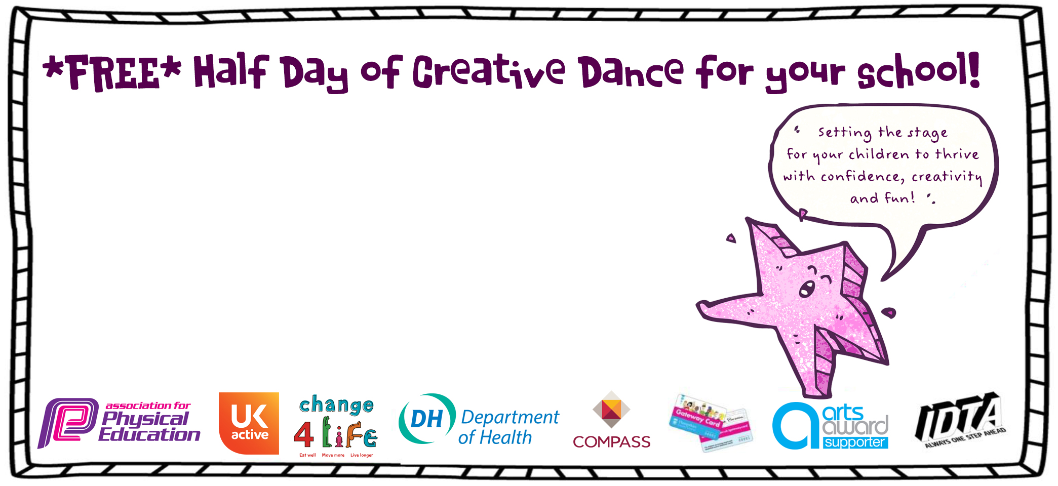

- This voucher entitles the school to one free half day of Creative Dance to be held during the spring/summer 1 term by Premier Performing Arts.

- To redeem, please contact your PPA Director to arrange, plan and confirm preferred activity dates. Voucher must be redeemed by 21st March 2014 to ensure availability of staff and resources.

Expiry date: 21st March 2014
Redeemable value: £95.00

