Friday 9th September 2016

New study reveals three quarters of UK’s children don’t even do 1 hour’s exercise a day
- Parents increasingly worried about childhood obesity -

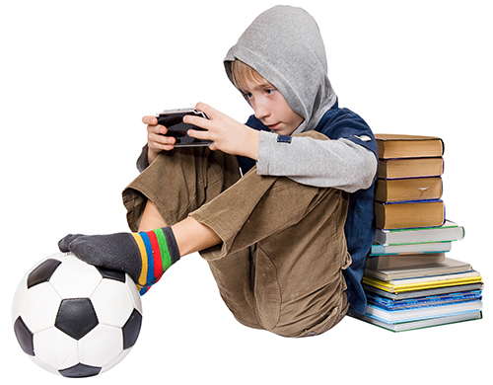
Premier Sport today published new research alarmingly revealing that only 10% of children are doing physical activity in every day, with over a quarter of parents believing their child is not doing enough and 60% are worried about obesity levels in their children.

According to the research, 85% of parents think their children would benefit from more education around fitness and half of parents agree that children should be properly fitness tested in schools.

Key stats from the nationwide study of 1000* parents across the UK;

- Only 10% of children are doing physical activity every day at school.
- Over half of parents think that children should be properly fitness tested in schools.
- 60% of parents are worried about obesity levels in children.
- 85% of parents think their children would benefit from more education around fitness in school with 50% suggesting their children should be properly tested in school.
- A quarter of parents admit they’re in the dark when it comes to knowing what physical activity their children’s school offer.
- Three quarters of our children don't even do 1 hour a day of exercise.
- A third of parents struggle to keep their children active.

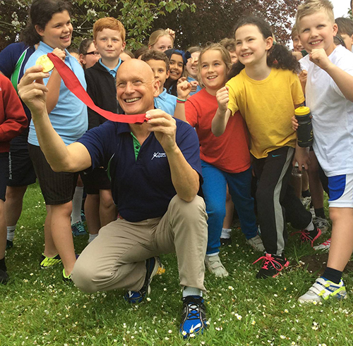
Commenting on the worrying statistics, Olympic gold medallist and Premier Sport ambassador, Duncan Goodhew, said: “It doesn’t seem right that we regularly measure numeracy and literacy skills in school children but we don’t regularly measure something that could potentially kill them! This has to change if we’re to curb the alarming rates of inactivity in our children.”

Addressing the concerns of the nation’s parents and their suggestion that the need for physical activity can begin at school, Premier Sport and ukactive joined forces to launch the ‘My Personal Best’ initiative, comprising of four fitness measures throughout the school year, with the aim of identifying periods when children become most inactive.

Based on evidence from the programme, appropriate interventions are put in place to ensure children with the most need are targeted and any investment/impact can be measured, particularly for girls whose activity levels begin to drop from age seven, statistically continuing through their teenage years.
ukactive Chair Baroness Tanni Grey-Thompson, said: “We know that today’s youth are the least active generation ever, so it’s vital that we intensify our efforts to embed a minimum of one hour of physical activity into their daily routines.

“Central to this should be the nationwide rollout of fitness measurement programmes for primary school children that are conducted in a way that is fun and enjoyable for kids.

“Research we conducted with Premier Sport around the ‘My Personal Best’ initiative highlighted the importance of structured physical activity sessions both in and out of school. That’s why we’re also calling for funding from the government’s soft drinks levy to be used beyond the schools gates to ensure that physical activity sessions are accessible to children all-year-round.”

Chief Executive of Premier Sport, David Batch, said: "The research proves that there is a nationwide need for further education and investment in to our children's fitness to create a year round approach to activity. Using meaningful and measurable interventions, in schools, to drive improvement will lead to a healthier understanding and natural step towards tackling underage obesity and inactivity.”

-Ends-

For further information & additional media materials or to set up an interview with Duncan Goodhew MBE, please contact:
Luke Miles, Premier Sport – lmiles@premier-education.com / 07557 979 522
Zoe Sobol, Essentially Group – zoe@snowballpr.co.uk / 07971 066 034
Alex Brown, Essentially Group – alex.brown@essentiallygroup.com / 07803 037 530

Notes to editor:

*Research conducted by Hartley UK

Premier Sport
Premier Sport is the UK's largest children's coaching company of its kind, successfully delivering more than 25,000 sport and physical activity sessions every month. Premier Sport supports teachers in their curriculum delivery and provides parents with an invaluable service before, during, afterschool and during holiday periods.

ukactive
ukactive is the UK's leading not-for-profit health body for the physical activity sector, with over 3,500 members from activity providers to major consumer brands, training facilities and equipment manufacturers. Members come from across the private, public and third sector and are united by ukactive's longstanding and uncompromising commitment to getting more people, more active, more often.

Olympic gold medallist and Premier Sport ambassador, Duncan Goodhew
Duncan is one of Premier Sport’s founding ambassadors and is a regular visitor to Premier's schools. He is passionate about inspiring children through sport, after overcoming hurdles including losing all his hair aged 10 and dyslexia, in his own childhood.

Childhood obesity and Sugar Tax Levy
As a first major step towards tackling childhood obesity, a soft drinks industry levy across the UK was recently introduced. In England, the revenue from the levy will be invested in programmes to reduce obesity and encourage physical activity and balanced diets for school age children. This includes doubling the Primary PE and Sport Premium.

