Premier Physical Activity and Wellbeing Proposal.

Working in Partnership with: {insert name}

School Name, School Address, phone number.

Created by {insert Name}
– {insert roll}
– {insert email/contact details}

Contents Page:
- Extended Partner school promise- Our commitment to you (Additional Value alongside service!)
- Referral and feedback – What do our schools and partners say?
- School portal – Evidencing the impact within your school
- Evidencing and Impact tables
- Pricing and provision information

- Extended Partner school promise- Our Commitment to You!
(Additional Value Alongside Service!)

Extended Partner School PROMISE!
- Annual School Governor Meeting – Evidencing to partnership and impact within the school

- Quality assurance/joint observation with Head teacher/governor/PE coordinator- Quality assure your provision with an Ofsted style report

- School Staff portal training session – Upskilling all staff within school to access planning/attainment information

- x3 action planning/review meetings with partnership development manager – supporting your school development plan

- Schools point of contact for any enquiries – Quality assurance and partnership development ongoing support
- x1 new sport enrichment day (Premier Sport) – Try something new enrichment day!

- Staff health and Wellbeing or CPD session (Fit Trition/CPD) – Whole School approach (your pupil needs you!)

- x1Premier performing arts taster day – link to special events such as world book day/international dance

- x1Free morning Premier Wellbeing – Whole school approach to becoming physically and mentally healthy

- FREE Competition (inter/intra academy days) – tackling key indicator 5 (increase participation in competitive sport)

- Golden Mile 50% discount – Achieve and measure your active 30 minutes in school per day!
We can further discuss all the above to ensure these are tailored to meet your schools’ individual needs.
Why choose Premier?
- Bespoke short, medium- and long-term PE planning framework accessed via online resource
- Online school portal Capturing data providing automated impact and progress evaluation
- Industry expert knowledge in PE, school sport, health & fitness, sport premium and OFSTED
- Lesson planning monitoring & support for class teachers utilising Premier resources
- OFSTED qualified inspections to review delivery
- Competition framework & school to club links
- Inspire’ programme working with key target groups of children (See Inspire Programme)
- UK active members – industry expert seminars & training days
- Industry relevant seminars such as afPE, Westminster briefings etc
- HR & Compliance ensure all staff have relevant qualifications and minimum operating standards. Premier’s strict Operating Standards (POS) are set above industry Minimum Operating Standards. (MOS)
- Ongoing CPD Journey and technical qualification in each individual sport delivered for every activity professional
- Staff sickness & absence cover included
- Industry leading insurance for up to £5,000,000
- Risk assessments
- Community sport support
- Ongoing assessment and Continued moderation i.e. 3 x observations per year as a minimum

How we can support OFSTED judgement of effective leadership and management:
- How will leaders pursue excellence and improve standards?
Premier staff are targeted and assessed on their professionalism and application. Using the scheme of work, they will support school needs and measure impact.
- Effectiveness of monitoring & evaluation and extent to which it is shared.
We monitor and evaluate performance before sharing with class teachers. All progress is recorded via school portal and guidance given for improvement.
- Robust performance management and effectiveness of strategy for improving teaching. Our staff members have explicit targets re. Performance, CPD and evaluations which are reviewed every half term.
- How well curriculum focusses on priorities for ensuring all pupils make excellent progress, meeting needs, aptitude and interest of pupils?
Premier’s curriculum framework is linked to learning and cross curriculum and the schedule meets the needs of pupils. Our community work on Higher Folds is also a direct link.
- Demonstrate capacity to bring about further improvement.
Regular reviews and guidance for sport, PE and pupils help to shape pro-active programmes and improvements.

- Referral and feedback – What do our schools say?
{Insert Referral Video}
EXAMPLE
Premier - School feedback video!

‘’ Our experience of working with Premier has been first class. They are a reliable organisation, sending high quality coaches to deliver outstanding Pe and enrichment opportunities’’ – Adam Bell, Stradbroke Academy, Head of school.

‘’What I find really useful is our regular review meetings…. this allows us to always be driving things forward’’ – Louise Spall, Somerleyton Primary School, Head teacher.

‘’Premier have very high expectations of all their staff members. Premier were also recognised as a strength of the school in our latest Ofsted report’’ Lindsay Hanger, Northgate Primary school, Head teacher.

- School portal – Evidencing the impact within your school
School Portal Log in Guide

Dear {insert name},

We are delighted to introduce to you our online school portal. This is where moving forward all short, medium- and long-term plans will be stored together with child assessments. This portal will be able to store all of these important documents which can be accessed at the click of a button by school staff.

This will be where we can track progress of children and measure our impact in school from term to term from the activities being delivered.

Please see below our step by step guide to access this information for your class.

Step 1 – enter https://schools.premier-education.com/ into internet search bar
Step 2 – email address –XXXXXXXX / password – XXXXXXX
Step 3 – My Home Page – Click Activities
Step 4 – On left hand side click assessments and attainment
Step 5 – Use tab on right hand side to change the terms etc. Once found correct term find your class and click the + button
Step 6 – This will bring up the main section for medium / short term planning and assessments
Step 7 – Find relevant section and click to access
Step 8 – Print off required documents if needed.

Office staff can use the portal for tracking online payments for parent paid EC and holiday club’s under Activities and Extra Curriculum Activities on left hand side.

Under the contacts section includes activity professional information to include DBS numbers, safeguarding and 1st aid certs together with sport qualifications.

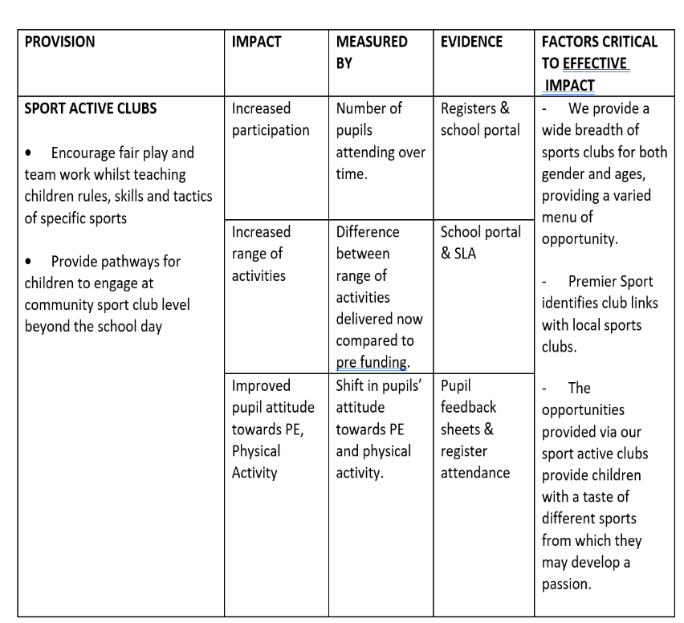
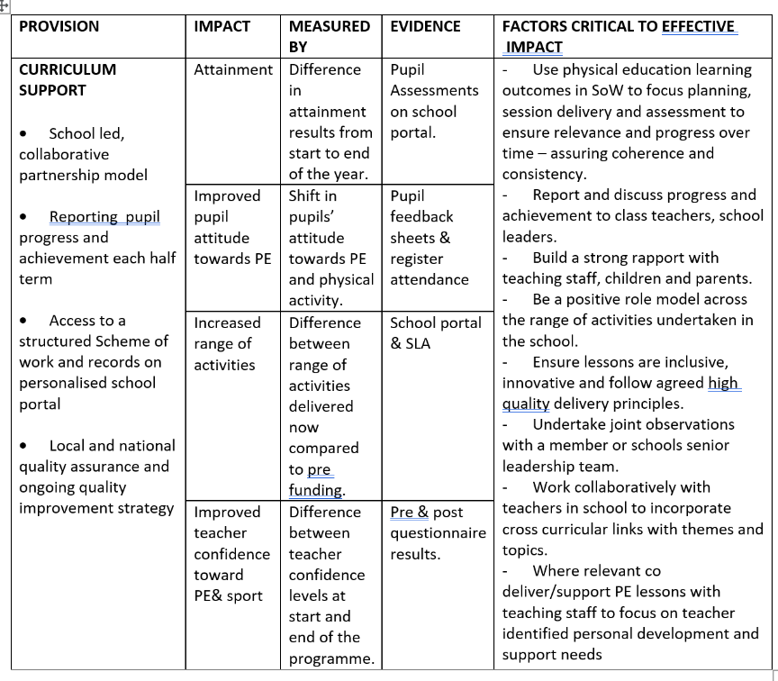
4. Evidencing and Impact tables

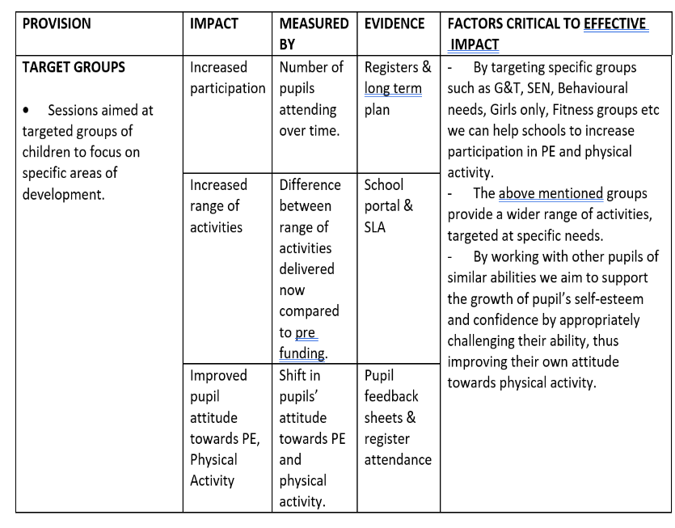
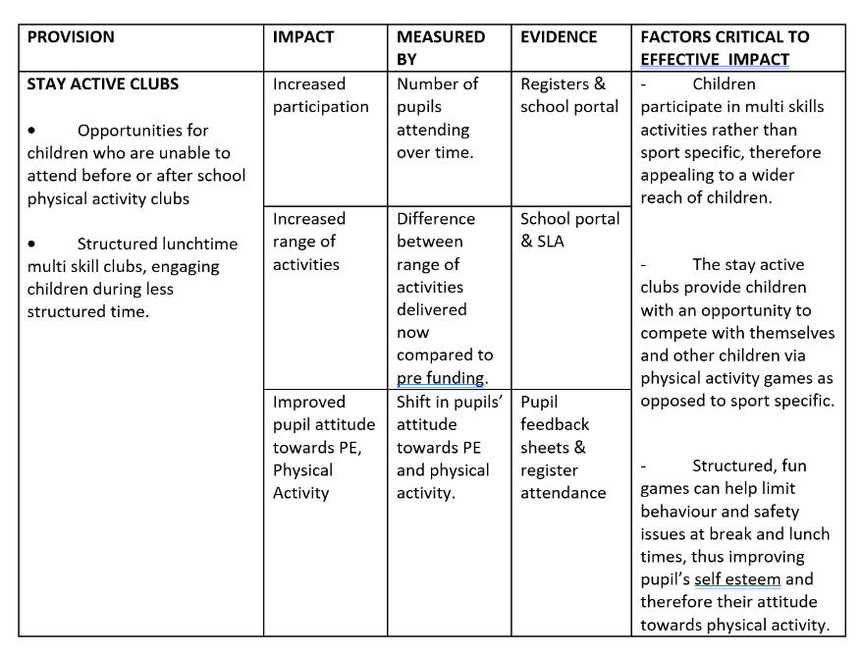

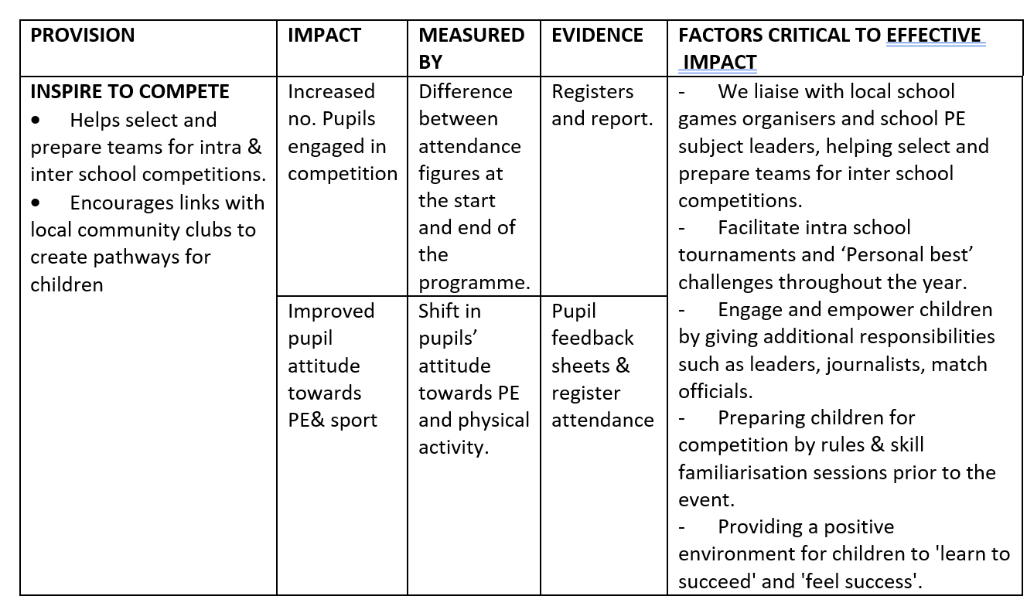

5.Pricing and provision package
Full day Curriculum support
{insert price}
Morning/Afternoon Curriculum support
{insert price} per morning/afternoon – (Morning = 3 hours/ Afternoon=2 hours)
Lunch Time Stay Active Provision
(Can Include Inspire to Compete / Target Groups Provision)
Monday – Friday {insert price} per session
After School Sport Active Provision
(Can Include Inspire to Compete / Target Groups Provision)
Monday – Friday {insert price} per session
Breakfast Start Active clubs
{insert price} per morning
Golden Mile Health & Physical Activity Initiative
{insert price} per year
Premier Wellbeing
Play Trition/Fun Trition- {insert price} per morning x 1 per week - 3 classes per morning
{insert annual cost}
Parent/Teacher Fit Trition x 1 per week - {insert price} per session

