National Schools Training
810 Birchwood Boulevard
Warrington WA3 7QZ
4th December 2015
Testimony of Good Practice
Dear Sir
I write to inform you of the excellent practice displayed by one of your coaches, John Gorner, on Thursday 26th November.
I am currently a Tutor / Assessor and my responsibilities are to guide Teaching Assistants through the Level 3 Supporting Teaching and Learning Diploma course. A vital component of the course is to observe good classroom practice through lesson observations.
I observed my student in a PE lesson led by John Gorner. As a PE practitioner / leader for over 30 years, the session I observed was one of the best I have ever seen. The lesson was fast paced, full of enthusiasm, content filled and, great fun.
My student will have learned a tremendous amount about delivery, classroom management, planning, subject knowledge and managing pupil behaviour.
Fortunately for me, I am now retired from classroom practice and I will not need to “raise my game” in PE sessions! The lesson was a joy to witness.
Yours sincerely
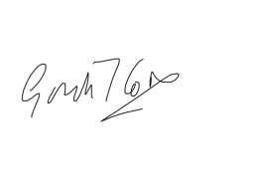

G T Core MA, NPQH, Dip Ed. (Ed.Man.) Cert Ed.

